**ITSE476**

**Book Store Management System**

**Developer Documentation:**

In This Documentation, We will explain our system source code. To help our contributors in understanding how we did build the system functionalities by breaking down the source code (Classes) into small parts and explaining them step by step.

1. Add Book Class:

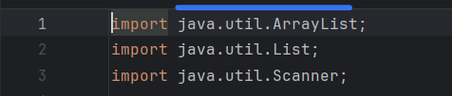

*This section imports necessary classes from the* ***java.util*** *package, including* ***ArrayList****,* ***List****, and* ***Scanner****, which are used in the code.*

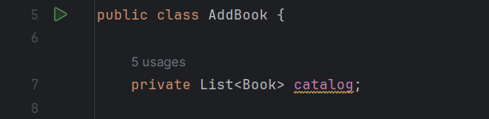

This line defines a class named **AddBook**. And , declares a private field named **catalog** of type **List<Book>**, which will store instances of the **Book** class.

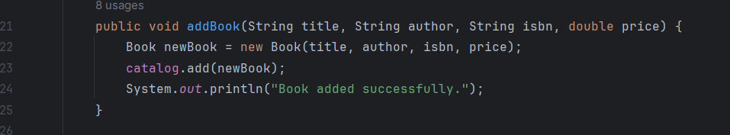

This method **addBook** adds a new book to the catalog. It takes parameters such as **title**, **author**, **isbn**, and **price** to create a new **Book** object, adds it to the **catalog**, and prints a success message.

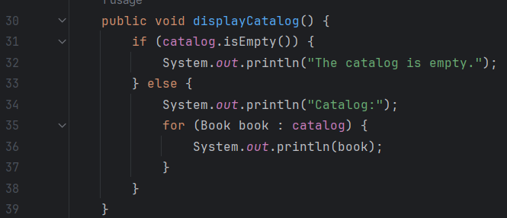

This method **displayCatalog** is responsible for displaying the current catalog of books. It iterates through the **catalog** and prints information about each book.

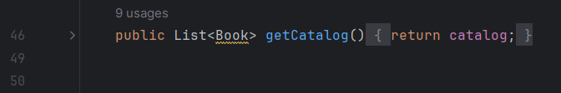

This method **getCatalog** returns the current catalog of books.

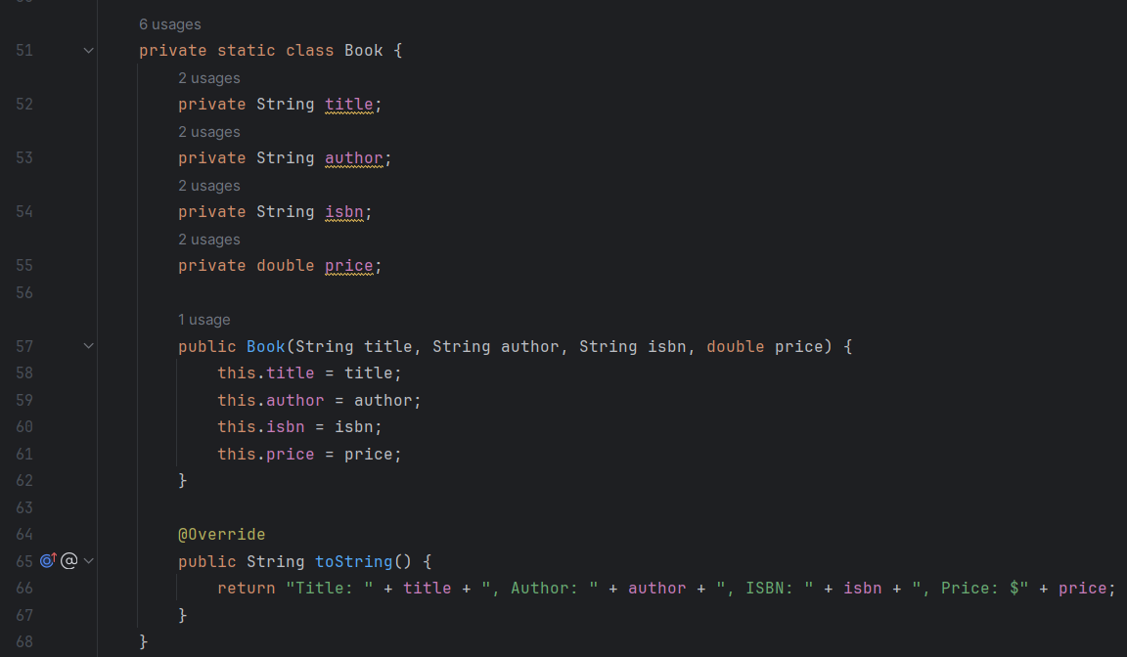

This is an inner class named **Book**, which represents a book object. It contains fields such as **title**, **author**, **isbn**, and **price**, along with a constructor to initialize these fields and a **toString** method to return a string representation of the book.

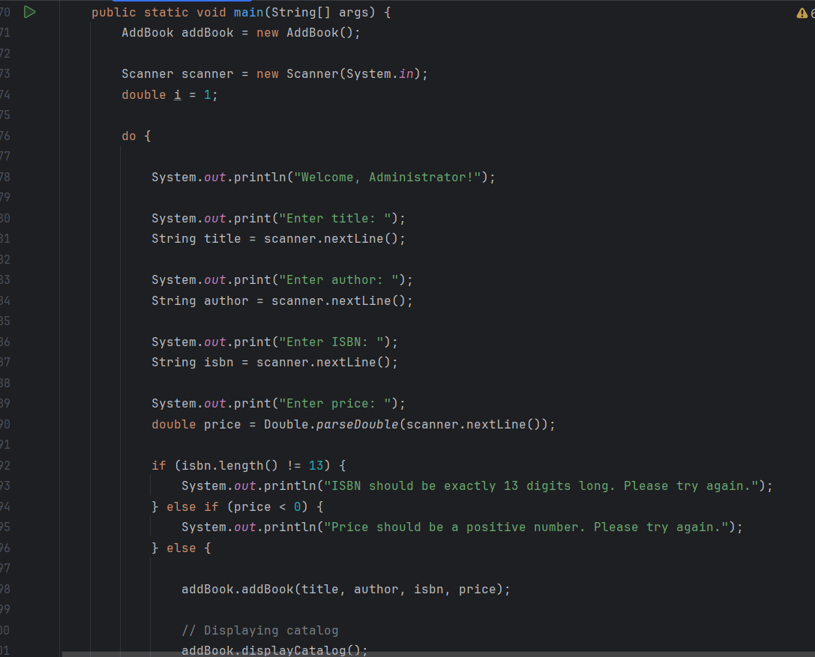

This is the main method, used for testing the **AddBook** class. It prompts the user to input details of a book, adds it to the catalog, displays the catalog, and then accesses the catalog using the **getCatalog** method.

1. Buy Book Class:  
     
   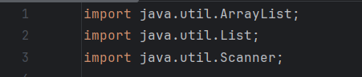

These lines import necessary classes from the **java.util** package, including **ArrayList**, **List**, and **Scanner**.

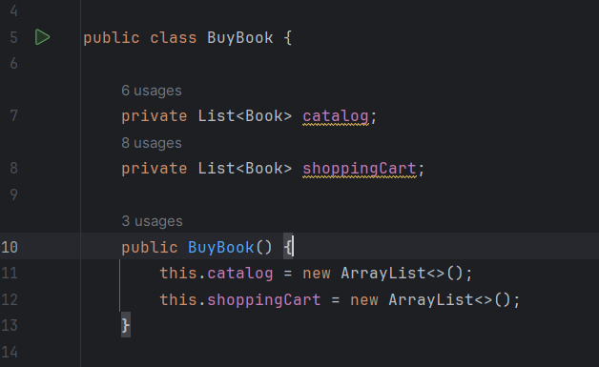

This first line defines a class named **BuyBook**.

These lines declare two private fields: **catalog** and **shoppingCart**, both of type **List<Book>**. **catalog** stores available books, and **shoppingCart** stores books that the user wants to buy. Also, the constructor of the **BuyBook** class. It initializes the **catalog** and **shoppingCart** fields as new **ArrayList** instances.

}

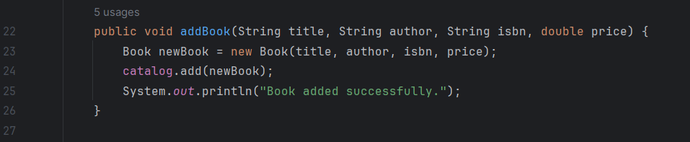

This method **addBook** adds a new book to the catalog. It takes parameters such as **title**, **author**, **isbn**, and **price** to create a new **Book** object and adds it to the **catalog**.

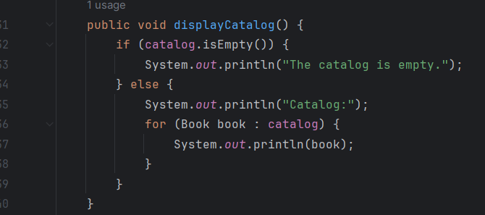

This method **displayCatalog** is responsible for displaying the current catalog of books. It iterates through the **catalog** and prints information about each book.

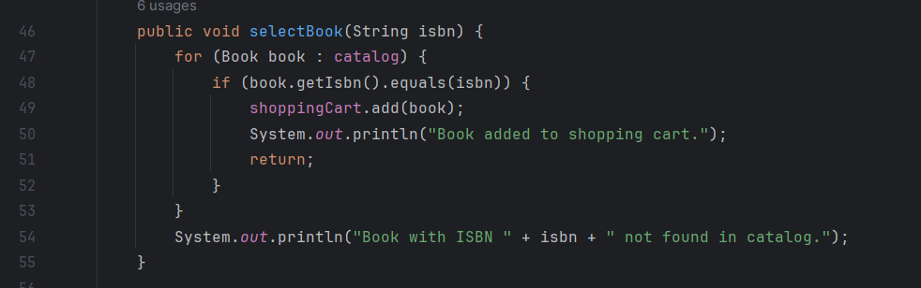

This method **selectBook** allows the user to select a book by its ISBN and adds it to their shopping cart if found in the catalog.

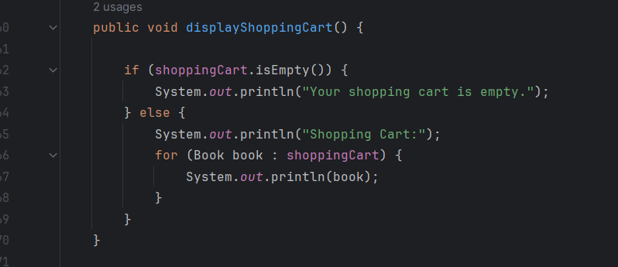

This method **displayShoppingCart** displays the current contents of the shopping cart. It iterates through the **shoppingCart** and prints information about each book.

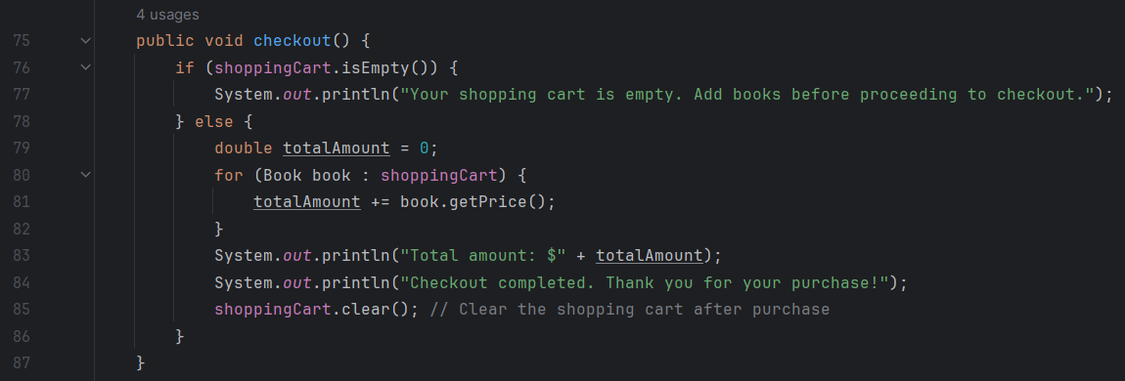

This method **checkout** calculates the total price of the books in the shopping cart, prints the total amount, and clears the shopping cart after completing the purchase transaction.

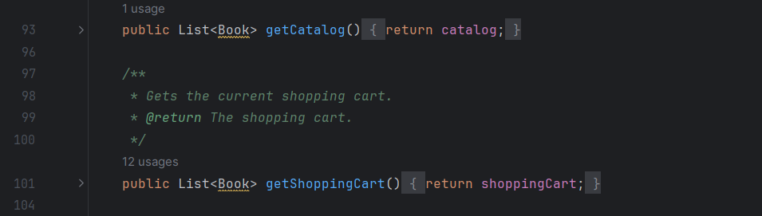

This method **getCatalog** returns the current catalog of books. And, this method **getShoppingCart** returns the current shopping cart.

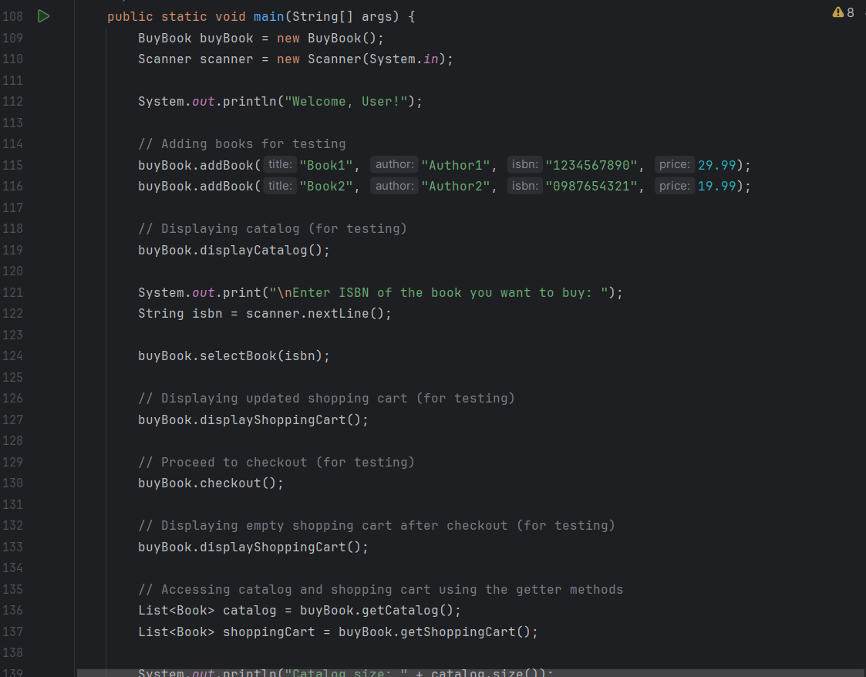

This is the main method, used for testing the **BuyBook** class. It adds some books to the catalog, allows the user to select a book to buy, displays the shopping cart, proceeds to checkout, and then displays the empty shopping cart after checkout.

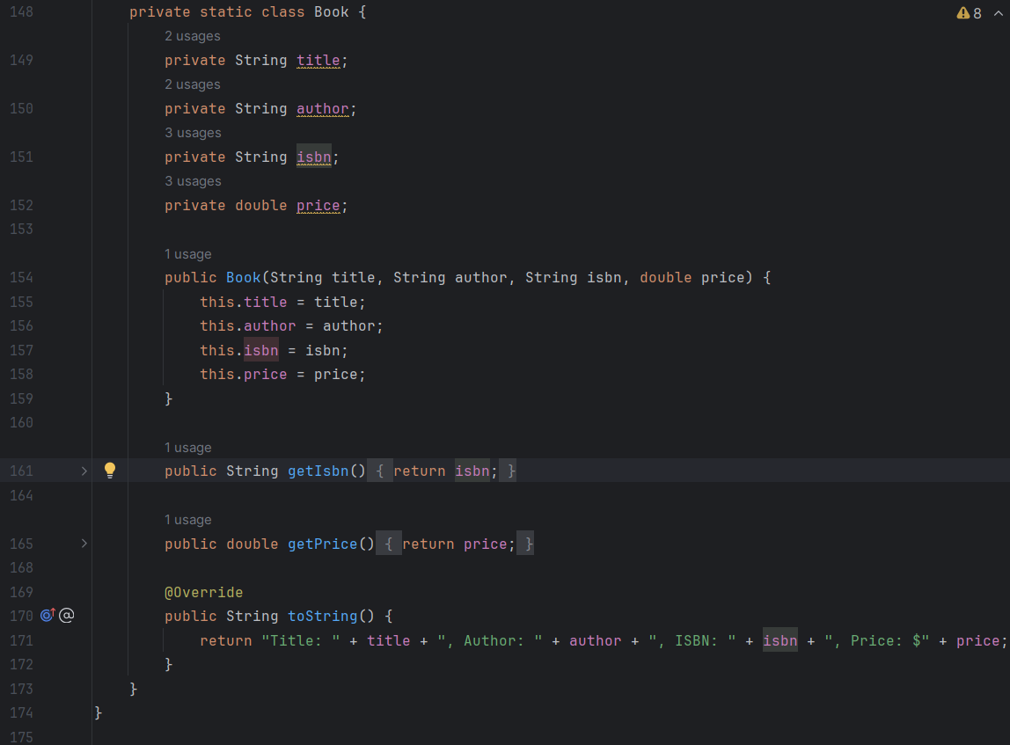

This is an inner class named **Book**, which represents a book object. It contains fields such as **title**, **author**, **isbn**, and **price**, along with a constructor to initialize these fields and getter methods to retrieve ISBN and price, and a **toString** method to return a string representation of the book.

1. Remove Book Class:



These lines import necessary classes from the **java.util** package, including **ArrayList**, **List**, and **Scanner**.

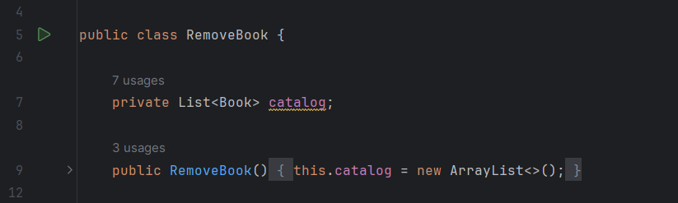

This line defines a class named **RemoveBook**. Also, declares a private field named **catalog** of type **List<Book>**, which will store instances of the **Book** class.

The constructor of the **RemoveBook** class. It initializes the **catalog** field as a new **ArrayList**.

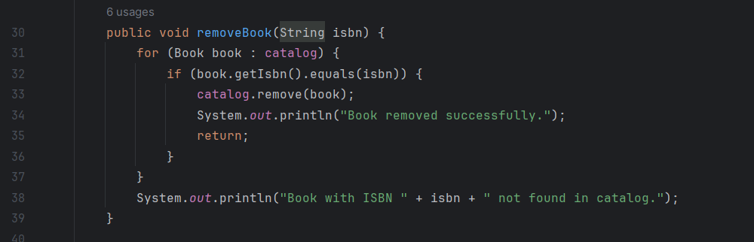

This method **removeBook** removes a book from the catalog based on its ISBN. It iterates through the **catalog** to find the book with the specified ISBN and removes it if found.

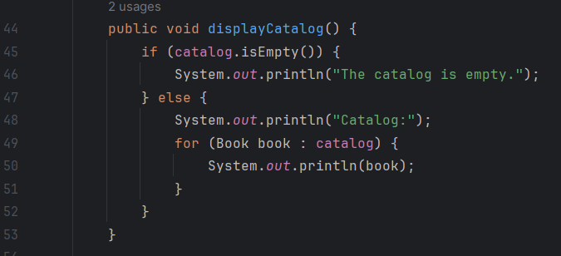

This method **displayCatalog** is responsible for displaying the current catalog of books. It iterates through the **catalog** and prints information about each book.

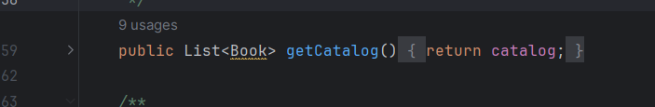

This method **getCatalog** returns the current catalog of books.

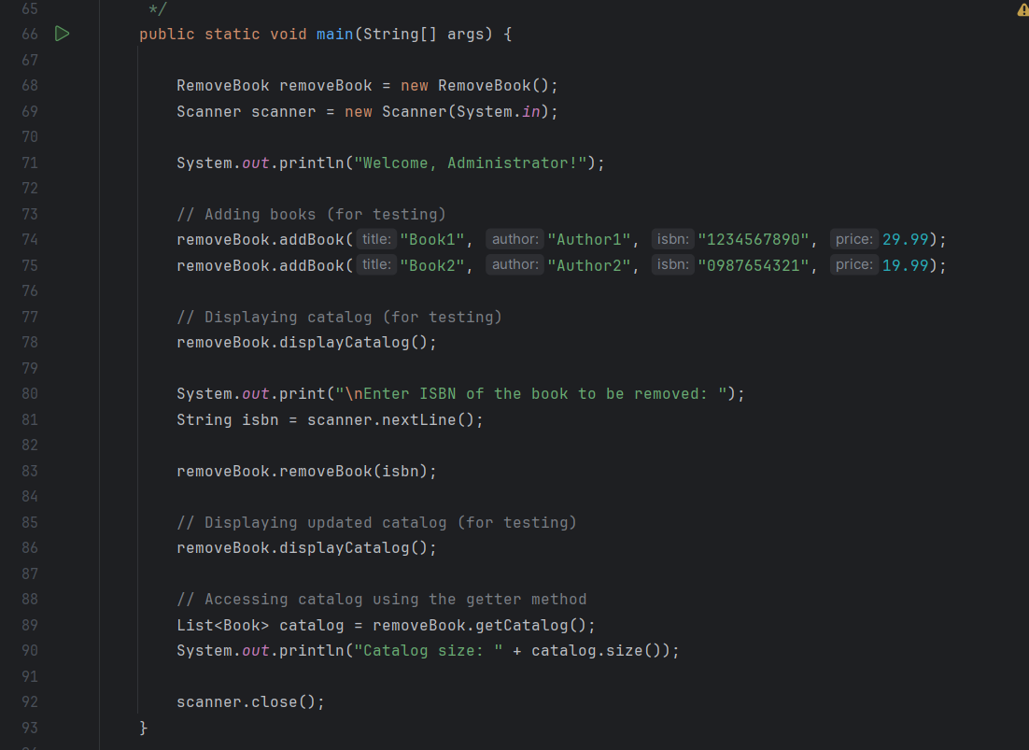

This is the main method, used for testing the **RemoveBook** class. It adds some books to the catalog, allows the user to enter the ISBN of the book to be removed, removes it from the catalog, and then displays the updated catalog.

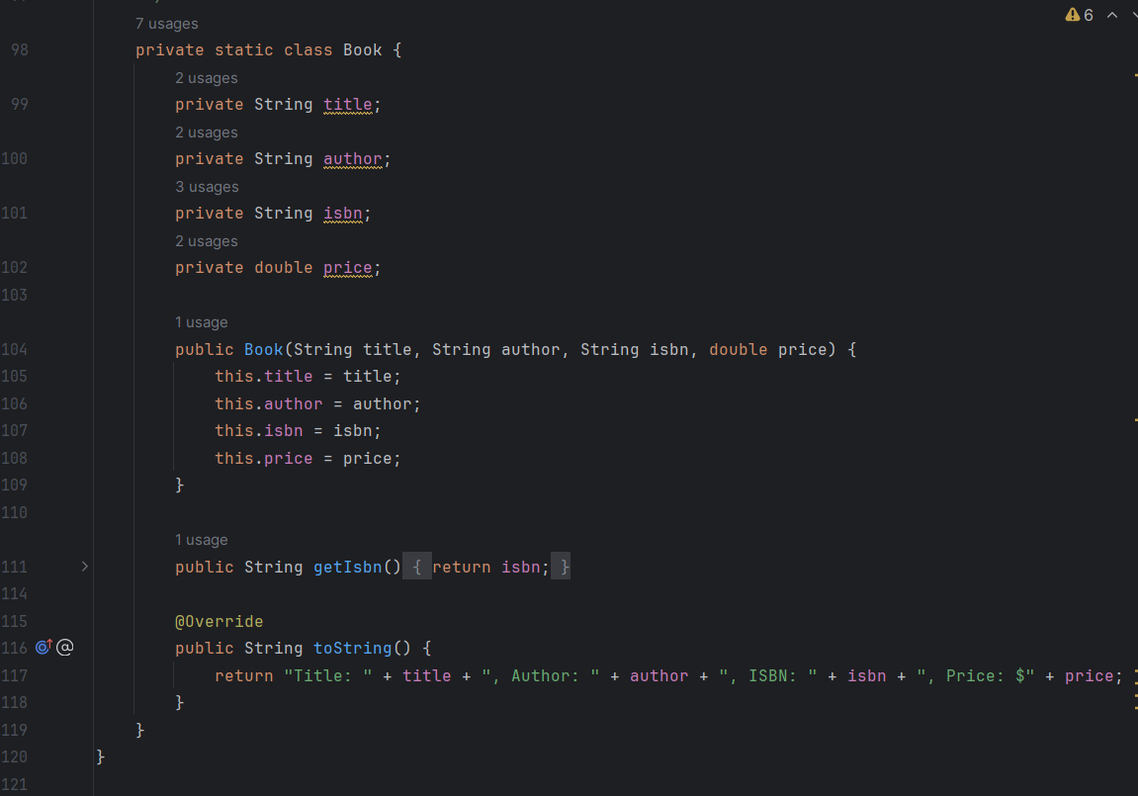

This is an inner class named **Book**, which represents a book object. It contains fields such as **title**, **author**, **isbn**, and **price**, along with a constructor to initialize these fields and a **toString** method to return a string representation of the book.